Sprint 3 Agility Design Document

November 26, 2019

Kiki Kanik

Bryan Le

Veronica Marquez

Table of Contents

1. Executive Summary 3

1.1 Project Overview 3

1.2 Purpose and Scope of this Specification 3

2. Product/Service Description 3

2.1 Product Context 3

2.2 User Characteristics 3

2.3 Assumptions 3

2.4 Constraints 3

2.5 Dependencies 4

3. Requirements 4

3.1 Functional Requirements 5

3.2 Security 5

3.2.1 Protection 5

3.2.2 Authorization and Authentication 6

3.3 Portability 6

4. Requirements Confirmation/Stakeholder sign-off 6

5. System Design 6

5.1 Algorithm 6

5.2 System Flow 6

5.3 Software 6

5.4 Hardware 6

5.5 Test Plan 7

5.6 Task List/Gantt Chart 7

5.7 Staffing Plan 7

# Executive Summary

## Project Overview

A robot must successfully travel around an intense obstacle around HH208 while being able to sustain movement through each obstacle. This project will be presented to the class of CS-104-03, Professor Eckert, and potentially any other staff or student in the Computer Science/Software Engineering department.

## Purpose and Scope of this Specification

The purpose of this project is to see if the robot can run through the obstacle without going out of the given parameters. The purpose of this specification is to test the ability of the robot to follow directions when given by the developer. The intended audiences are all students and staff in the Computer Science/ Software Engineering department who have a well-rounded knowledge of the project and the concepts surrounding the project.

# Product/Service Description

Sphero edu is a company that is based around teaching and educating students about math, science, arts, social studies, and coding. Specifically, we are using a robot that was created by Sphero called “BOLT” to be used to help teach students (and those interested) how to code.

Sphero’s BOLT has an electric senor that can be used to detect light. It also has a compass in it that can be used to direct the robot north. The robot has Bluetooth and can be connected to one device at a time. There is an app that can be download on types of devices to command the robot using javascript/block code.

Factors that could potentially affect the product’s performance is its software, the personal ability of the sphere robot and the knowledge and precision of the user. Since the robot is spherical, it is not precise in its movements. Depending on the user’s precision and placement, the route of the robot can be perfect or very off. The software of the robot has not been made to accommodate this issue, but otherwise, it is very user-friendly.

## Product Context

This product relates to other products by the self-operating function. Other products such as a Roomba are programmed to go around the whole house and vacuum. It is self-contained. Yes, it does interface with a variety of related systems. The robot relies on the Sphero app and coding to be able to function in the way the user desires it to function.

## User Characteristics

|  |  |  |  |
| --- | --- | --- | --- |
| USER | EXPERIENCE LEVEL | TECHNICAL EXPERIENCE | REASON FOR USING BOLT |
| Student | Beginner | None | Competition / to learn how to code / class project |
| Student | Intermediate | Some | Competition / to hone coding skills /class project |
| Student | Advanced | A lot | Competition / for fun / class project |
| Faculty | Beginner | None | Because Prof Eckert asked them |
| Faculty | Intermediate | Some | Because Prof Eckert asked them |
| Faculty | Advanced | A lot | Because Prof Eckert asked them |
| Random | Beginner | None | For fun / to help teach |
| Random | Intermediate | Some | For fun / to help teach |
| Random | Advanced | A lot | For fun / to help teach |

## Assumptions

The robot will be connected to Bluetooth to operate/run

The robot runs on block/JavaScript code

The robot will be able to complete the course provided for by Prof Eckert

## Constraints

* There may be an updated and better operating system.
* Security may be weak b/c others could have access to the code that’s programmed in the robot
* Robot’s framework is a sphere so you can’t accurately point it in the direction you want it to go to.

## Dependencies

The robot requires coding in order for it to operate.

It requires testing so it can operate correctly and efficiently.

# Requirements

1. The robot must be programmed to meet task requirements.
2. The robot must successfully travel around the room without interruption.
3. The robot must run the figure 8 course
4. The robot must run and complete the obstacle course

## Functional Requirements

|  |  |  |  |  |  |
| --- | --- | --- | --- | --- | --- |
| Req# | Requirement | Comments | Priority | Date Rvwd | SME Reviewed / Approved |
| ENDUR_01 | The robot should start and finish in the same place as indicated by the course | Have to find a way to code the robot so it can go through the course | 1 | 11/10/19 | 11/19/19 |
| ENDUR_02 | The robot should go through the obstacles without going out of the parameters | we have  to find a way to aim the robot perfectly so the robot doesn’t stray from the path | 2 | 11/10/19 | 11/22/19 |
| ENDUR_03 | The robot should go around the obstacles in one run | Create a run that will let the robot go around just once | 3 | 11/10/19 | 11/22/19 |
| ENDUR_04 | The robot must be able to go over the “ramp” and still follow through to the end | In the program we have to take in consideration this “bump” in the obstacle | 4 | 11/10/19 | 11/19/19 |
| ENDUR_05 | The robot must be able to knock down as many “pins” as possible without damaging itself | In the program we have to take into consideration the speed of the robot so it doesn't damage itself | 5 | 11/10/19 | 11/19/19 |

## Security

### Protection

“We responsibly source critical components from trusted vendors & suppliers.  We also audit our factories for ethical worker treatment. The hardware that we create is loaded with ﬁrmware that is developed to ensure proper functionality and security of the system. Each robot we create is built with a batch serial number to identify any issues that may arise, and to facilitate logistics.”

### Authorization and Authentication

Sphero edu promises authenticity with all its products. An internal security review and audits are done routinely on their products. There is an automated security monitoring that Sphero provides on all it’s products to check on the code and o fix any issues that may arise. Verified data Encryption. Sphero follows the guidelines drawn up by the Children's Online Privacy Protection Act (COPPA) to ensure the safety and privacy of child users.

To find out more about the product’s security, click on the hyperlink below: <https://s3.amazonaws.com/static.gosphero.com/downloads/infographic/Sphero-Safety-Infographic.pdf>

## Portability

The Sphero code is portable because it can be used from multiple devices to work, such as desktop, laptop, iPad, phones

# Requirements Confirmation/Stakeholder sign-off

|  |  |  |
| --- | --- | --- |
| Meeting Date | Attendees (name and role) | Comments |
| 11/19/19 | Bryan Le (Assistant Manager)  Kiki Kanik (Management)  Veronica Marquez (Project Manager) | We each went over our tasks and approved the code |
| 11/22/19 | Bryan Le (Assistant Manager)  Kiki Kanik (Management)  Veronica Marquez (Project Manager) | We went over what each member has done thus far since meeting on 11/19/19. Discussed any problems the team was facing and tried to resolve them if possible. |
| 11/25/19 | Bryan Le (Assistant Manager)  Kiki Kanik (Management)  Veronica Marquez (Project Manager) | We went over the last finishing touches of all areas of the project which include code, document, flow chart, gnatt chart |

# System Design

## Algorithm

1. Place the robot on the blue X where the obstacle will take place
2. Roll 0 degrees at a speed of 63 for 2.3 seconds
3. Stop, wait for 2 second
4. Roll 90 degrees at a speed of 63 for 2.3 seconds
5. Stop, wait 2 second
6. Roll 0 degrees at a speed of 63 for 2.3 seconds
7. Stop, wait 2 second
8. Roll 90 degrees at a speed of 63for 2.3 seconds
9. Stop, wait for 2 second
10. Roll 225 degrees at a speed of 120 for 3 seconds

## System Flow

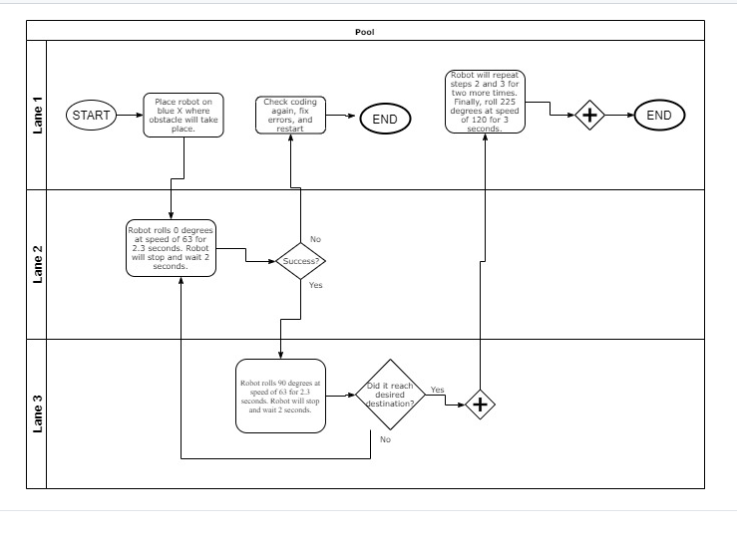

## Software

The software that will be used to develop this project is block coding, including javascript behind the block coding itself.

## Hardware

The hardware that is going to be used is to ensure the project will run is a

## Test Plan

|  |  |  |  |  |  |
| --- | --- | --- | --- | --- | --- |
| **Reason for Test Case** | **Test Date** | **Expected Output** | **Observed Output** | **Staff Name** | **Pass/Fail** |
| Aim the robot | 11/19/19 | The blue light will be aimed towards the direction needed | The blue light was aimed properly towards wanted direction | Veronica Marquez | Pass |
| Run robot | 11/19/19 | The robot will go from start position heading towards the obstacle course | The robot went in the opposite direction, away from the starting point | Veronica Marquez | Fail |
| Re-aim robot | 11/19/19 | The blue light will be aimed again towards the direction wanted | The blue light was aimed as wanted | Veronica Marquez | Pass |
| Re-run robot | 11/19/19 | The robot will go from start position heading towards the obstacle course | The robot went towards the obstacle course, blue light was aimed correctly | Veronica Marquez | Pass |
| Robot stays on the path | 11/19/19 | To ensure robot goes from starting point to the next point, staying on the path | The robot went out of the path | Veronica Marquez | Fail |
| Re-run robot to stay on the path | 11/19/19 | To ensure the robot goes from starting point to the next point | The robot went out of the path once again | Veronica Marquez | Fail |
| Re-aim robot | 11/19/19 | The blue light will be aimed once again to ensure it is properly straight so the robot doesn’t go off the path | The blue light was aimed as straight as I thought it was | Veronica Marquez | Pass |
| Re-run robot to see if it stays on the path till the “ramp” | 11/22/19 | To ensure robot will  stay on the path from starting point to complete the obstacle up to the “ramp” | Robot stayed on the path | Veronica Marquez | Pass |
| Ran the robot from start to ramp | 11/22/19 | To ensure the robot endure going over the ramp | Once robot went over the ramp it went out of the course completely | Veronica Marquez | Fail |
| Re-run the robot from start to finish | 11/22/19 | To ensure robot will continue on the course after it goes over the “ramp” | Robot stayed on the path for the whole run except for the endpoint it missed the  “pins” | Veronica Marquez | Fail |
| Re-aimed the robot | 11/22/19 | To ensure the blue light is as straight towards the direction wanted | The blue light was aimed as straight as I thought was necessary | Veronica Marquez | Pass |
| Re-run the robot from the start to finish | 11/22/19 | To ensure the robot can endure going around the whole course without going out of the parameters given | The robot went around the whole course successfully and stayed in the blue figure without going out | Veronica Marquez | Pass |
| Run the robot from start to finish once again | 11/26/19 | To ensure the code and the robot are still consistent | The robot went through the whole obstacle course without any current problems | Veronica Marquez | Pass |

## Task List/Gantt Chart

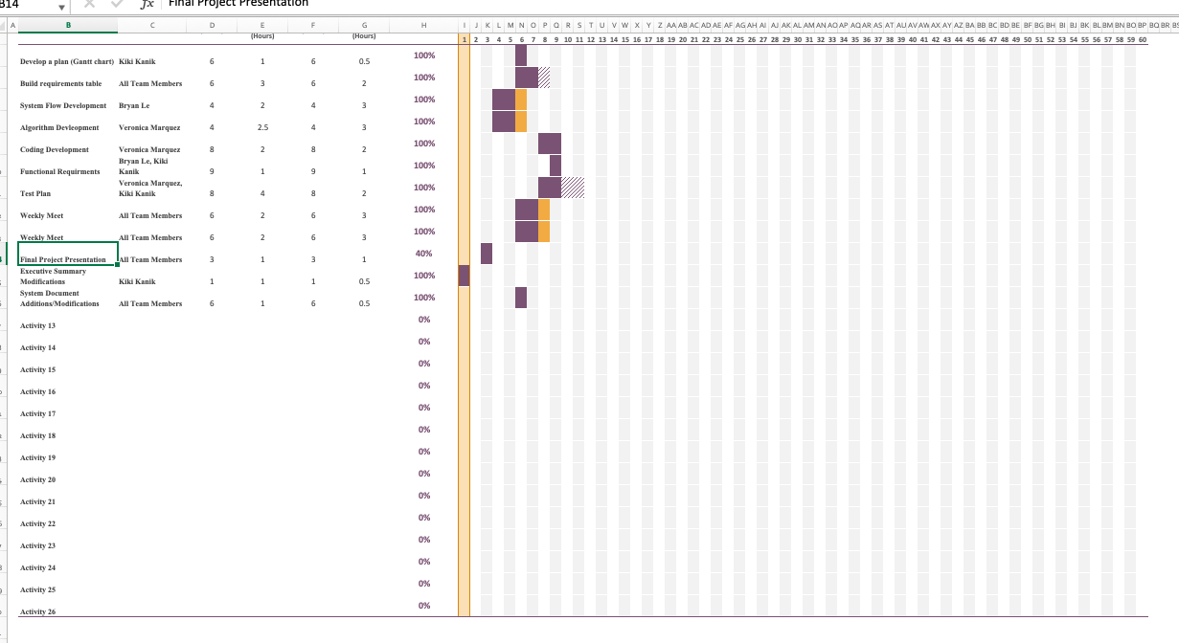

## Staffing Plan

|  |  |  |  |
| --- | --- | --- | --- |
| **Name** | **Role** | **Responsibility** | **Reports To** |
| **Veronica Marquez** | Project Manager, Coder, Tester | Responsible for all project deliverables, update the project plan.  Write the code that will allow the robot to achieve the requirements.  Test the written code to ensure no errors are presented with the robot and the code itself. | Prof. Eckert, Team |
| **Kiki Kanik** | Management | Paperwork, Co-Tester | Prof. Eckert, Team |
| **Bryan Le** | Assistant Manager | Complete Documents | Prof. Eckert Team |